**✅ Section 2: SQL (30–45 mins)**

**Dataset:** [Chinook Database (Music Store)](https://github.com/lerocha/chinook-database)

You can run it on [SQLite Online](https://sqliteonline.com/) or import into any SQL IDE.

**Tasks:**

1. List the top 5 customers by total purchase amount.

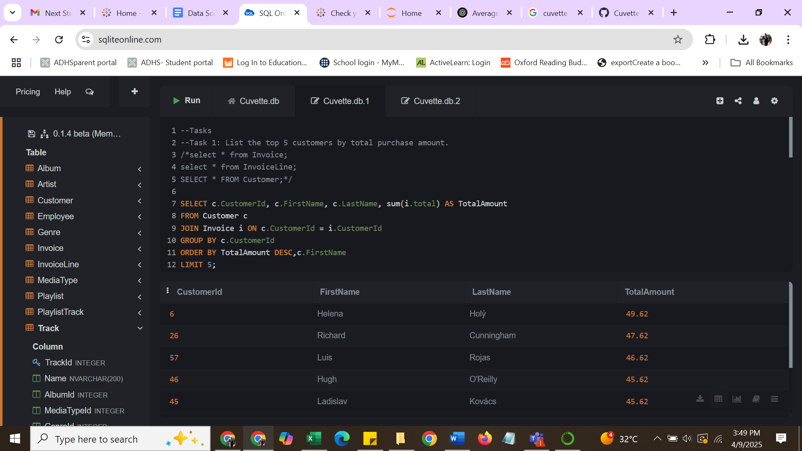

1. Find the most popular genre in terms of total tracks sold.

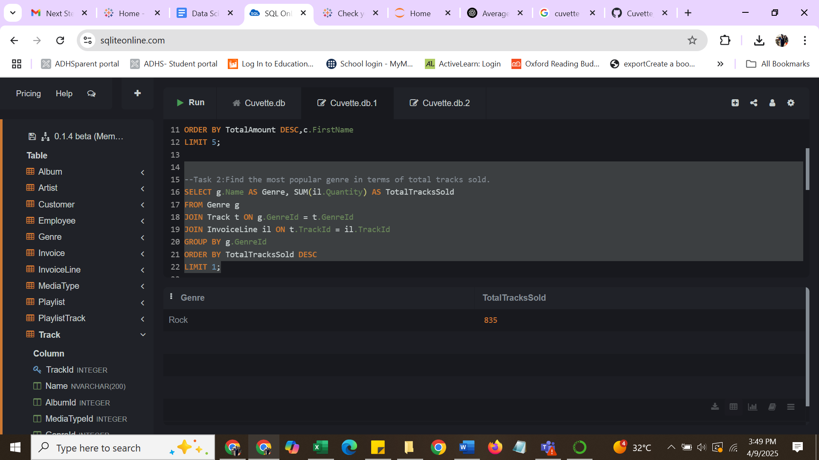

1. Retrieve all employees who are managers along with their subordinates.

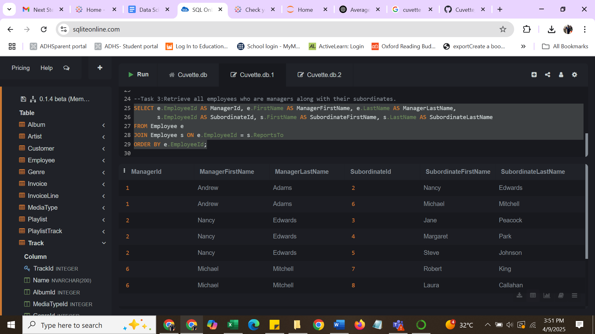

1. For each artist, find their most sold album.

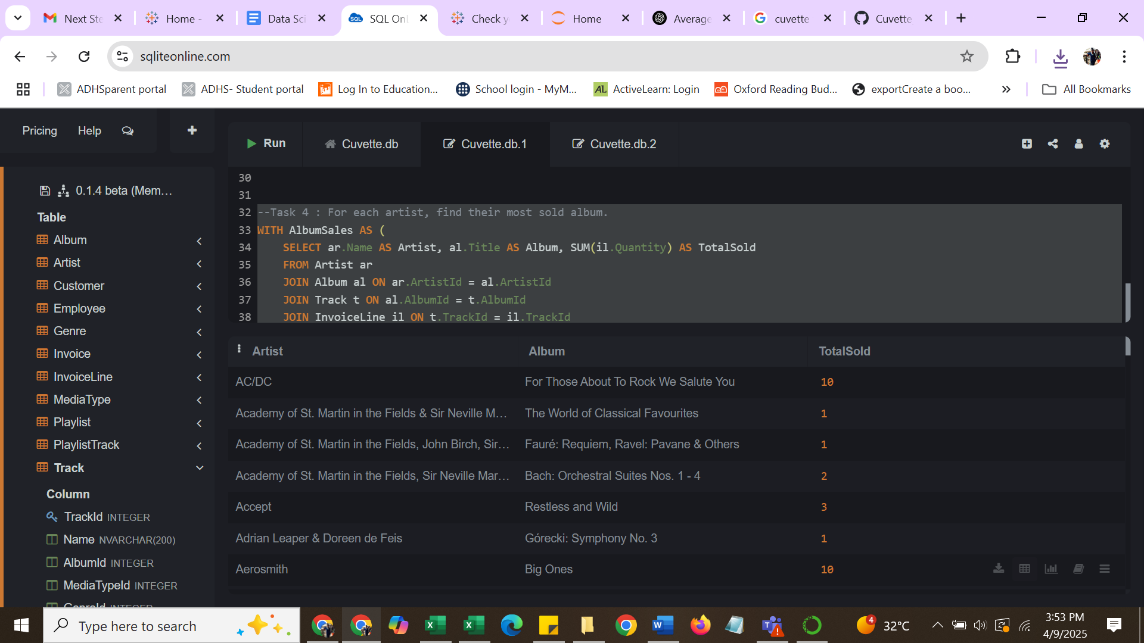

|  |  |  |
| --- | --- | --- |
| AC/DC | For Those About To Rock We Salute You | 10 |
| Academy of St. Martin in the Fields & Sir Neville Marriner | The World of Classical Favourites | 1 |
| Academy of St. Martin in the Fields, John Birch, Sir Neville Marriner & Sylvia McNair | FaurÃ©: Requiem, Ravel: Pavane & Others | 1 |
| Academy of St. Martin in the Fields, Sir Neville Marriner & Thurston Dart | Bach: Orchestral Suites Nos. 1 - 4 | 2 |
| Accept | Restless and Wild | 3 |
| Adrian Leaper & Doreen de Feis | GÃ³recki: Symphony No. 3 | 1 |
| Aerosmith | Big Ones | 10 |
| Alanis Morissette | Jagged Little Pill | 8 |
| Alice In Chains | Facelift | 7 |
| Amy Winehouse | Back to Black | 12 |
| Antal DorÃ¡ti & London Symphony Orchestra | Tchaikovsky: 1812 Festival Overture, Op.49, Capriccio Italien & Beethoven: Wellington's Victory | 1 |
| AntÃ´nio Carlos Jobim | Chill: Brazil (Disc 2) | 15 |
| Apocalyptica | Plays Metallica By Four Cellos | 4 |
| Aquaman | Aquaman | 2 |
| Audioslave | Audioslave | 6 |
| BackBeat | BackBeat Soundtrack | 6 |
| Battlestar Galactica | Battlestar Galactica, Season 3 | 12 |
| Battlestar Galactica (Classic) | Battlestar Galactica (Classic), Season 1 | 18 |
| Berliner Philharmoniker & Hans Rosbaud | Sibelius: Finlandia | 1 |
| Berliner Philharmoniker & Herbert Von Karajan | Grieg: Peer Gynt Suites & Sibelius: PellÃ©as et MÃ©lisande | 1 |
| Billy Cobham | The Best Of Billy Cobham | 4 |
| Black Label Society | Alcohol Fueled Brewtality Live! [Disc 1] | 5 |
| Black Sabbath | Black Sabbath Vol. 4 (Remaster) | 7 |
| Body Count | Body Count | 11 |
| Bruce Dickinson | Chemical Wedding | 12 |
| Buddy Guy | The Best Of Buddy Guy - The Millenium Collection | 7 |
| Caetano Veloso | Prenda Minha | 19 |
| Calexico | Carried to Dust (Bonus Track Version) | 1 |
| Chicago Symphony Orchestra & Fritz Reiner | Scheherazade | 2 |
| Chico Buarque | Minha Historia | 27 |
| Chico Science & NaÃ§Ã£o Zumbi | Afrociberdelia | 16 |
| Chris Cornell | Carry On | 4 |
| Cidade Negra | AcÃºstico MTV [Live] | 9 |
| ClÃ¡udio Zoli | Na Pista | 5 |
| Creedence Clearwater Revival | Chronicle, Vol. 2 | 19 |
| CÃ¡ssia Eller | CÃ¡ssia Eller - ColeÃ§Ã£o Sem Limite [Disc 2] | 12 |
| David Coverdale | Into The Light | 8 |
| Deep Purple | Come Taste The Band | 5 |
| Def Leppard | Vault: Def Leppard's Greatest Hits | 7 |
| Dennis Chambers | Outbreak | 4 |
| Djavan | Djavan Ao Vivo - Vol. 02 | 9 |
| Dread Zeppelin | Un-Led-Ed | 1 |
| Ed Motta | The Best of Ed Motta | 6 |
| Edo de Waart & San Francisco Symphony | Adams, John: The Chairman Dances | 1 |
| Elis Regina | Elis Regina-Minha HistÃ³ria | 13 |
| Emanuel Ax, Eugene Ormandy & Philadelphia Orchestra | Chopin: Piano Concertos Nos. 1 & 2 | 1 |
| Emerson String Quartet | Schubert: The Late String Quartets & String Quintet (3 CD's) | 2 |
| English Concert & Trevor Pinnock | Pachelbel: Canon & Gigue | 1 |
| Equale Brass Ensemble, John Eliot Gardiner & Munich Monteverdi Orchestra and Choir | Purcell: Music for the Queen Mary | 2 |
| Eric Clapton | Unplugged | 25 |
| Eugene Ormandy | Holst: The Planets, Op. 32 & Vaughan Williams: Fantasies | 1 |
| Faith No More | Album Of The Year | 13 |
| Falamansa | Deixa Entrar | 8 |
| Felix Schmidt, London Symphony Orchestra & Rafael FrÃ¼hbeck de Burgos | Elgar: Cello Concerto & Vaughan Williams: Fantasias | 1 |
| Foo Fighters | In Your Honor [Disc 2] | 6 |
| Frank Sinatra | My Way: The Best Of Frank Sinatra [Disc 1] | 10 |
| Frank Zappa & Captain Beefheart | Bongo Fury | 4 |
| Funk Como Le Gusta | Roda De Funk | 8 |
| Gene Krupa | Up An' Atom | 17 |
| Gilberto Gil | Quanta Gente Veio Ver (Live) | 13 |
| Godsmack | Faceless | 8 |
| Gonzaguinha | Meus Momentos | 9 |
| Green Day | International Superhits | 18 |
| Guns N' Roses | Use Your Illusion I | 17 |
| GÃ¶teborgs Symfoniker & Neeme JÃ¤rvi | Nielsen: The Six Symphonies | 1 |
| Habib KoitÃ© and Bamada | Muso Ko | 1 |
| Heroes | Heroes, Season 1 | 13 |
| House Of Pain | House of Pain | 8 |
| Incognito | Blue Moods | 9 |
| Iron Maiden | The X Factor | 11 |
| JET | Get Born | 7 |
| James Brown | Sex Machine | 12 |
| Jamiroquai | Synkronized | 7 |
| Jimi Hendrix | Are You Experienced? | 8 |
| Joe Satriani | Surfing with the Alien (Remastered) | 4 |
| Jorge Ben | Jorge Ben Jor 25 Anos | 6 |
| Jota Quest | Jota Quest-1995 | 6 |
| JoÃ£o Suplicy | Cafezinho | 6 |
| Judas Priest | Living After Midnight | 10 |
| Julian Bream | J.S. Bach: Chaconne, Suite in E Minor, Partita in E Major & Prelude, Fugue and Allegro | 1 |
| Kent Nagano and Orchestre de l'OpÃ©ra de Lyon | Weill: The Seven Deadly Sins | 1 |
| Kiss | Greatest Kiss | 20 |
| Led Zeppelin | BBC Sessions [Disc 2] [Live] | 10 |
| LegiÃ£o Urbana | A TempestadeTempestade Ou O Livro Dos Dias | 9 |
| Lenny Kravitz | Greatest Hits | 26 |
| Lost | Lost, Season 2 | 13 |
| Luciana Souza/Romero Lubambo | Duos II | 1 |
| Lulu Santos | Lulu Santos - RCA 100 Anos De MÃºsica - Ãlbum 01 | 8 |
| Marcos Valle | Chill: Brazil (Disc 1) | 7 |
| Marillion | Misplaced Childhood | 5 |
| Marisa Monte | Barulhinho Bom | 8 |
| Martin Roscoe | Szymanowski: Piano Works, Vol. 1 | 1 |
| Marvin Gaye | Seek And Shall Find: More Of The Best (1963-1981) | 10 |
| Maurizio Pollini | Beethoven Piano Sonatas: Moonlight & Pastorale | 1 |
| Men At Work | The Best Of Men At Work | 8 |
| Metallica | Garage Inc. (Disc 2) | 12 |
| Michael Tilson Thomas & San Francisco Symphony | Berlioz: Symphonie Fantastique | 2 |
| Michele Campanella | Liszt - 12 Ã‰tudes D'Execution Transcendante | 1 |
| Miles Davis | Miles Ahead | 7 |
| Milton Nascimento | Milton Nascimento Ao Vivo | 8 |
| MotÃ¶rhead | Ace Of Spades | 6 |
| MÃ´nica Marianno | Demorou... | 6 |
| MÃ¶tley CrÃ¼e | Motley Crue Greatest Hits | 7 |
| Nirvana | From The Muddy Banks Of The Wishkah [Live] | 7 |
| O Rappa | Radio Brasil (O Som da Jovem Vanguarda) - Seleccao de Henrique Amaro | 7 |
| O TerÃ§o | Compositores | 13 |
| Olodum | Olodum | 10 |
| Orchestra of The Age of Enlightenment | Bach: The Brandenburg Concertos | 1 |
| Os Mutantes | Minha HistÃ³ria | 8 |
| Os Paralamas Do Sucesso | AcÃºstico MTV | 18 |
| Otto Klemperer & Philharmonia Orchestra | Beethoven: Symphony No. 6 'Pastoral' Etc. | 1 |
| Ozzy Osbourne | Tribute | 10 |
| Page & Plant | Walking Into Clarksdale | 8 |
| Passengers | Original Soundtracks 1 | 9 |
| Paul D'Ianno | The Beast Live | 5 |
| Pearl Jam | Live On Two Legs [Live] | 9 |
| Philharmonia Orchestra & Sir Neville Marriner | Mendelssohn: A Midsummer Night's Dream | 1 |
| Pink Floyd | Dark Side Of The Moon | 4 |
| Planet Hemp | Os CÃ£es Ladram Mas A Caravana NÃ£o PÃ¡ra | 9 |
| Queen | Greatest Hits II | 14 |
| R.E.M. | The Best Of R.E.M.: The IRS Years | 17 |
| R.E.M. Feat. Kate Pearson | Out Of Time | 9 |
| Raimundos | Cesta BÃ¡sica | 7 |
| Raul Seixas | Raul Seixas | 10 |
| Red Hot Chili Peppers | Blood Sugar Sex Magik | 10 |
| Roger Norrington, London Classical Players | Purcell: The Fairy Queen | 1 |
| Royal Philharmonic Orchestra & Sir Thomas Beecham | Haydn: Symphonies 99 - 104 | 1 |
| Rush | Retrospective I (1974-1980) | 6 |
| Santana | Supernatural | 6 |
| Scholars Baroque Ensemble | Handel: The Messiah (Highlights) | 1 |
| Scorpions | 20th Century Masters - The Millennium Collection: The Best of Scorpions | 5 |
| Sir Georg Solti & Wiener Philharmoniker | Wagner: Favourite Overtures | 1 |
| Skank | Maquinarama | 6 |
| Smashing Pumpkins | Rotten Apples: Greatest Hits | 13 |
| Soundgarden | A-Sides | 15 |
| Spyro Gyra | Heart of the Night | 11 |
| Stevie Ray Vaughan & Double Trouble | In Step | 9 |
| Stone Temple Pilots | Core | 10 |
| System Of A Down | Mezmerize | 12 |
| Temple of the Dog | Temple of the Dog | 4 |
| Terry Bozzio, Tony Levin & Steve Stevens | [1997] Black Light Syndrome | 5 |
| The 12 Cellists of The Berlin Philharmonic | South American Getaway | 1 |
| The Black Crowes | Live [Disc 1] | 7 |
| The Clash | The Singles | 10 |
| The Cult | Pure Cult: The Best Of The Cult (For Rockers, Ravers, Lovers & Sinners) [UK] | 9 |
| The Doors | The Doors | 4 |
| The King's Singers | English Renaissance | 1 |
| The Office | The Office, Season 3 | 16 |
| The Police | The Police Greatest Hits | 7 |
| The Posies | Every Kind of Light | 1 |
| The Rolling Stones | Voodoo Lounge | 7 |
| The Tea Party | Tangents | 10 |
| The Who | My Generation - The Very Best Of The Who | 19 |
| Tim Maia | Serie Sem Limite (Disc 1) | 12 |
| TitÃ£s | AcÃºstico | 22 |
| Toquinho & VinÃ­cius | VinÃ­cius De Moraes - Sem Limite | 15 |
| U2 | Rattle And Hum | 17 |
| UB40 | UB40 The Best Of - Volume Two [UK] | 8 |
| Van Halen | The Best Of Van Halen, Vol. I | 10 |
| Various Artists | Vozes do MPB | 11 |
| Velvet Revolver | Contraband | 6 |
| VinÃ­cius De Moraes | Vinicius De Moraes | 6 |
| Yehudi Menuhin | Bartok: Violin & Viola Concertos | 1 |
| Yo-Yo Ma | Bach: The Cello Suites | 1 |
| Zeca Pagodinho | Ao Vivo [IMPORT] | 9 |

1. Write a query to get monthly sales trends in the year 2013.

No data is available for 2013

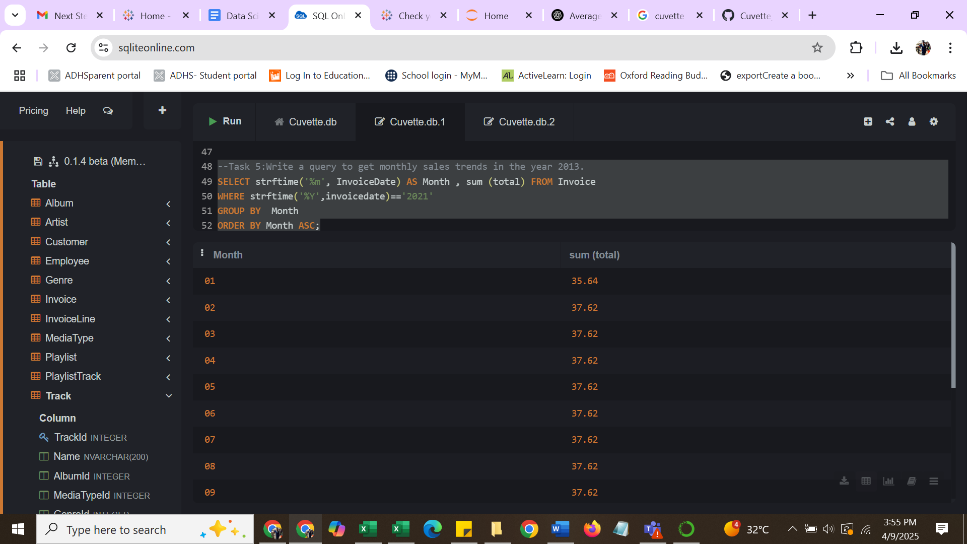

Submit a .sql file with queries and output screenshots.